SCD 1 Implementation – will hold only current information, if the record does not exists then insert, if exists check for changes

As of now we are overwriting the fields with new time.

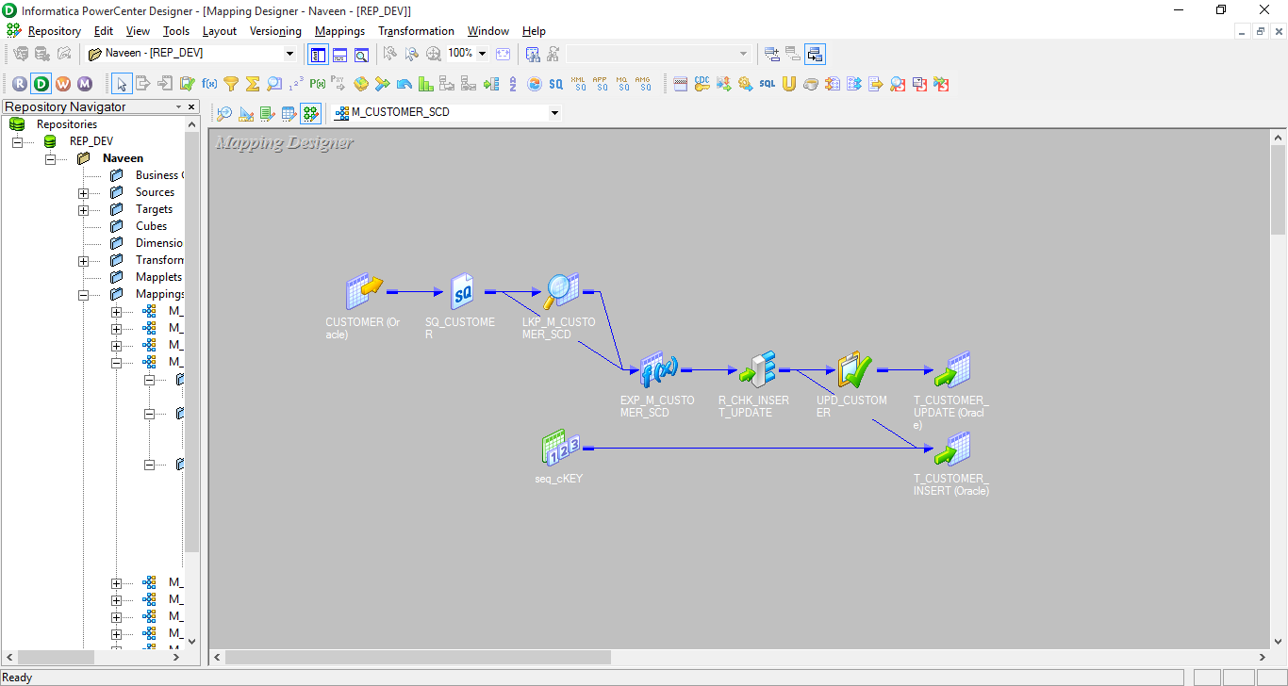

SCD1 TRANSFORMATION

-- SOURCE TABLE

CREATE TABLE CUSTOMER

( "CID" NUMBER,

"CNAME" VARCHAR2(33 ),

"ADDR_1" VARCHAR2(33 ),

"ADDR_2" VARCHAR2(33 ),

"STATE" VARCHAR2(33 ),

PRIMARY KEY ("CID"));

INSERT INTO CUSTOMER VALUES (1, 'SREEDHAR', 'AMERICAN DREAMWAY', '1ST STREET', 'RESTON');

INSERT INTO CUSTOMER VALUES (2, 'KUMAR', '8TH CORSS', 'BANGALORE', 'KARNATAKA');

INSERT INTO CUSTOMER VALUES (3, 'BECKY', 'DREAM CORNER', 'CLARA LANE', 'VIRGINIA');

INSERT INTO CUSTOMER VALUES (4, 'CHAITRA', 'MK COLONY', 'HRR', 'KARNATAKA');

COMMIT;

-- TARGET TABLE

CREATE TABLE T_CUSTOMER

( "CKEY" NUMBER,

"CID" NUMBER,

"CNAME" VARCHAR2(33 BYTE),

"ADDR_1" VARCHAR2(33 BYTE),

"ADDR_2" VARCHAR2(33 BYTE),

"STATE" VARCHAR2(33 BYTE),

"CREATE_DATE" DATE,

"UPDATE_DATE" DATE,

PRIMARY KEY ("CKEY"));

Take the source qualifier from customer table

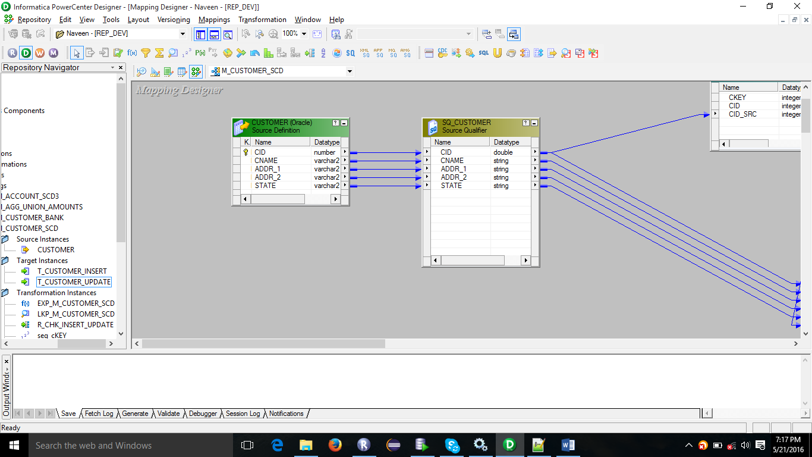

Create a lookup have only CKEY which is a surrogate key, and cid because we will compare only with that, whether the record exists or not. Create an port in lookup port called CID_SRC and drag and drop CID to CID_SRC, such that we can lookup.

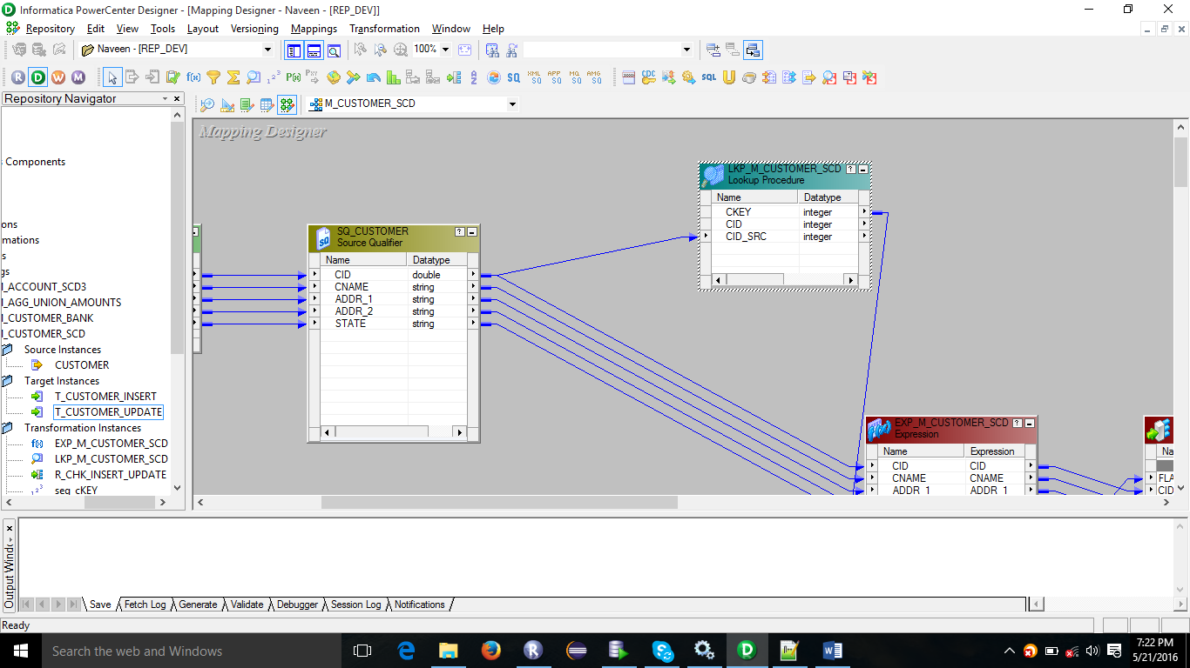

Create an expression EXP_M_CUSTOMER_SCD

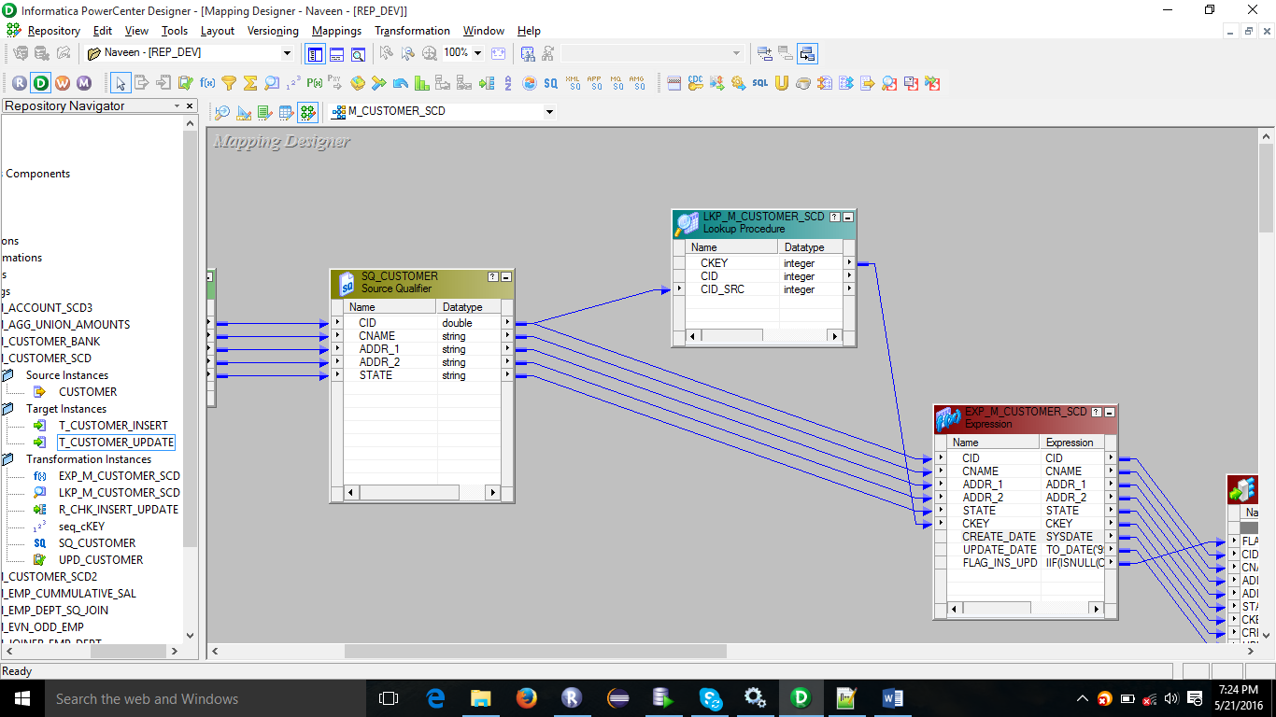

In expression

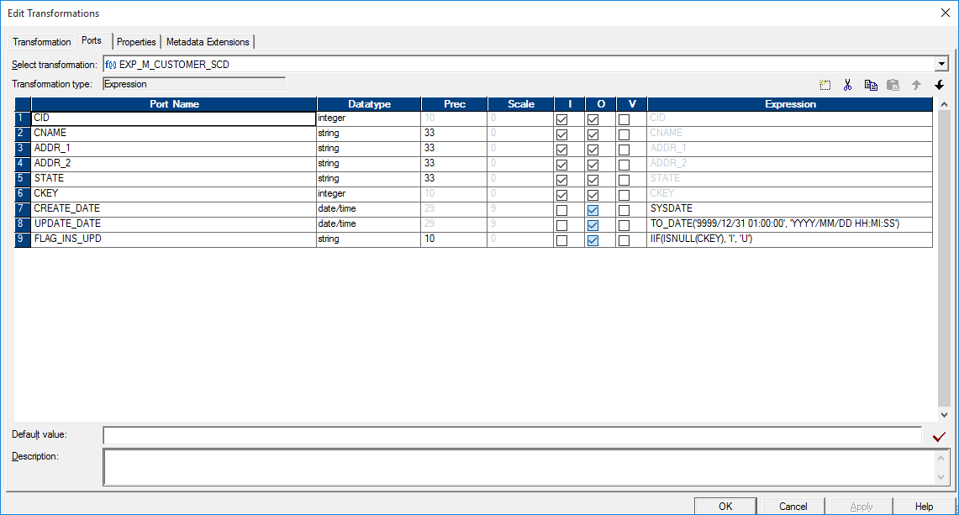

Create_date is sysdate, update_date is dummy date, flag for insert or update IIF(ISNULL(CKEY),’I’, ‘U’))

Create a router, with 2 groups with values I and U

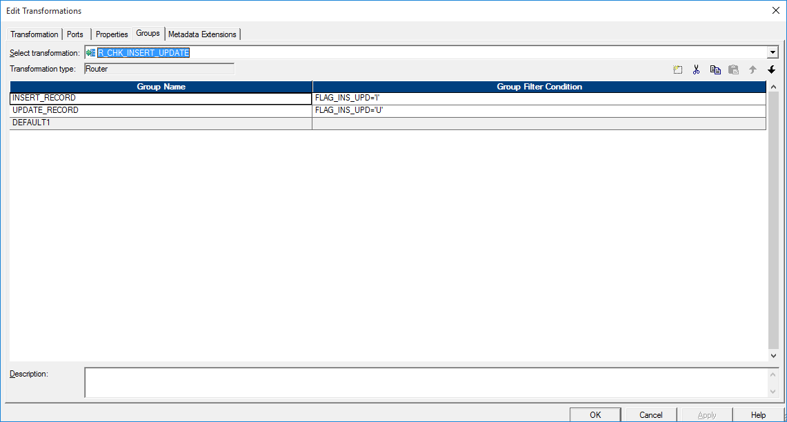

Here we have to do two things If the record is existing we have to update and if not existing need to be inserted.

For updating existing record we will use Update Strategy

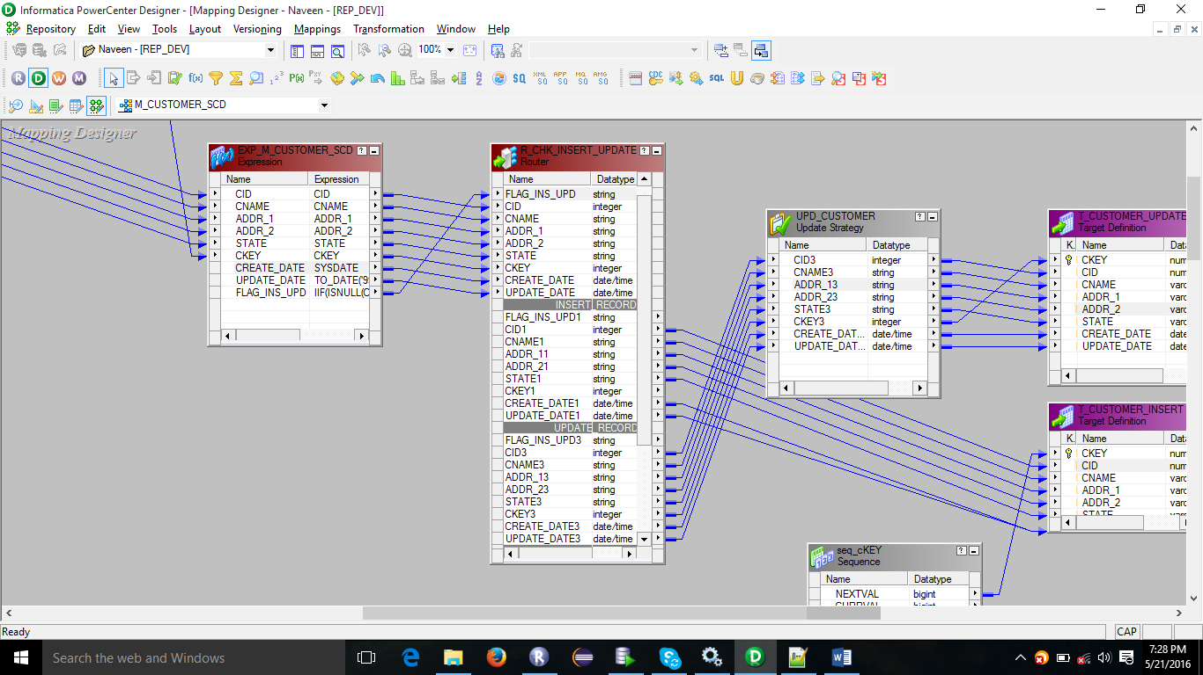

Case 1: Insert

Create a sequence

Target Definition will take all attributes except ckey, give ckey value from sequence created

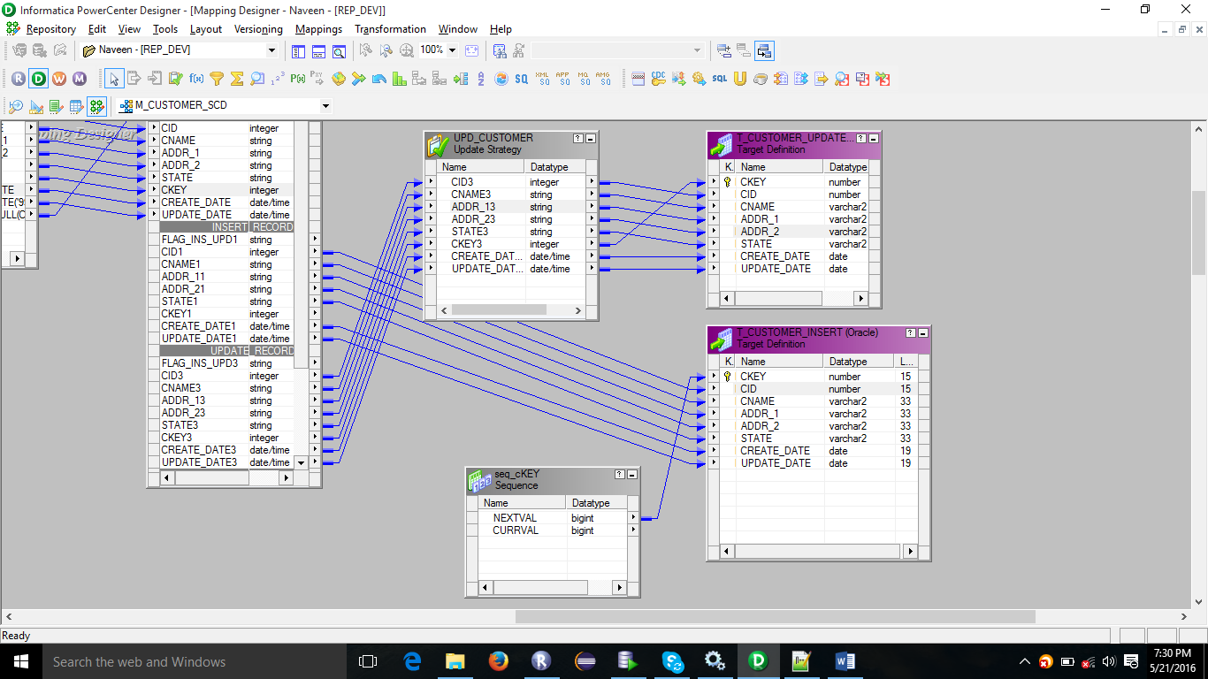

Case 2: Update

Create update strategy

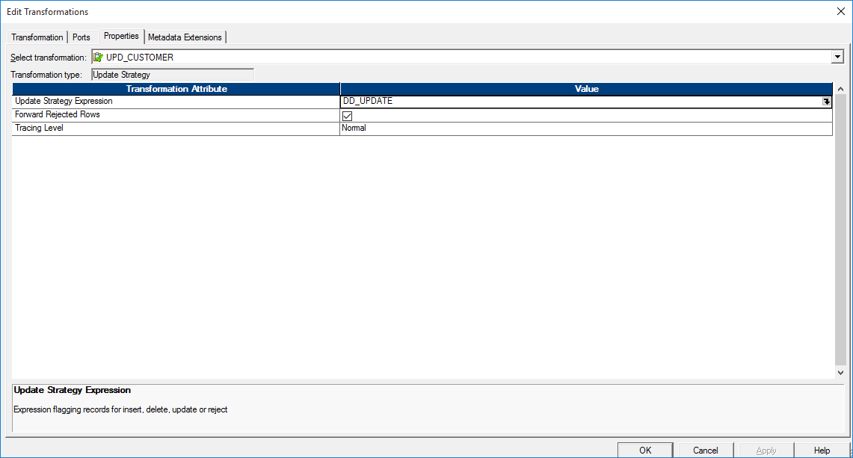

And drag all fields as shown below

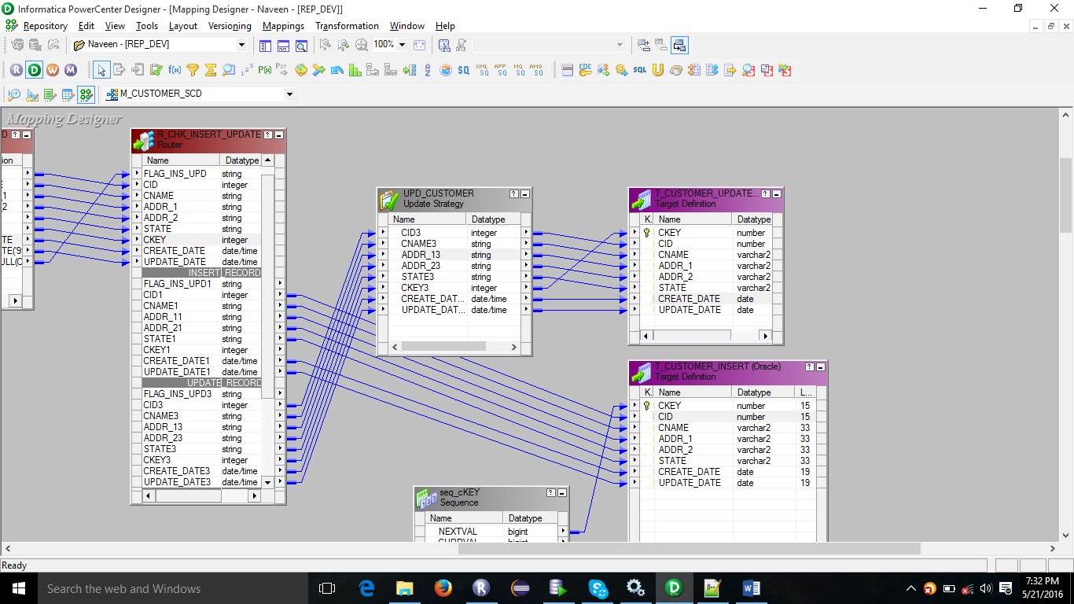

**SCD TYPE 2 IMPLEMENTAION**

* If not
  + Create a new entry along with create date(current date) and update date(future date)
* If Yes
  + New Entry with current Date and update date
  + Look for matching record and update date with current date

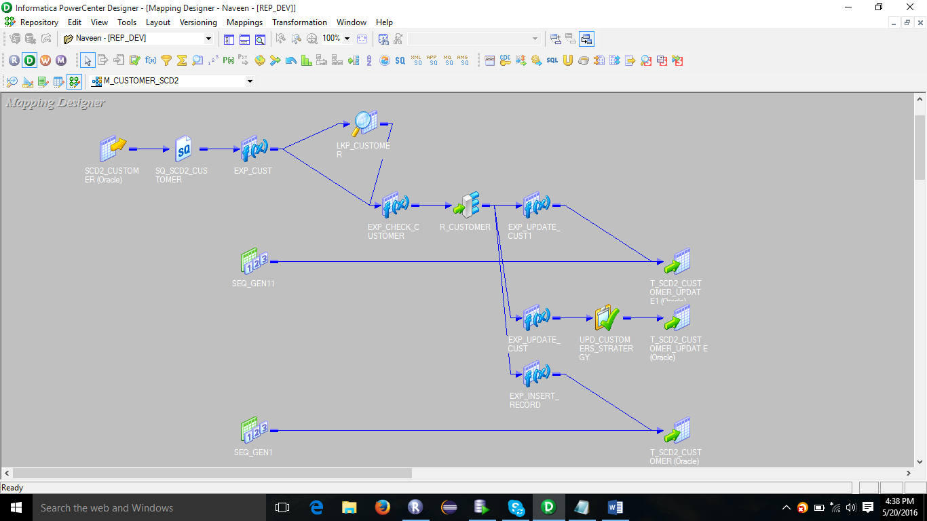

CREATE TABLE SCD2_CUSTOMER(

CUSTID VARCHAR2(5) PRIMARY KEY,

CUSTNAME VARCHAR2(33),

CUSTGRADE CHAR(1),

INCOME NUMBER(9,2));

INSERT INTO SCD2_CUSTOMER VALUES('C1', 'KUMAR', 'B', 232323);

INSERT INTO SCD2_CUSTOMER VALUES('C2', 'NAVEEN', 'B', 132323);

INSERT INTO SCD2_CUSTOMER VALUES('C3', 'SAM', 'A', 432323);

INSERT INTO SCD2_CUSTOMER VALUES('C4', 'DON', 'D', 31113);

-- TARGET TABLE

CREATE TABLE T_SCD2_CUSTOMER(

CUST_SKEY NUMBER PRIMARY KEY, -- SORROGATE KEY

CUSTID VARCHAR2(5),

CUSTNAME VARCHAR2(33),

CUSTGRADE CHAR(1),

INCOME NUMBER(9,2),

CUST_HASHCODE VARCHAR2(255),

START_DATE DATE,

END_DATE DATE,

CUST_FLAG CHAR(1));

Expression exp_cust is used as a best practice, from exp_cust take in_cust id other will be taken from lookup

In lookup sql override

SELECT T_SCD2_CUSTOMER.CUST_SKEY as CUST_SKEY, T_SCD2_CUSTOMER.CUST_HASHCODE as CUST_HASHCODE, T_SCD2_CUSTOMER.CUSTID as CUSTID FROM T_SCD2_CUSTOMER

WHERE

T_SCD2_CUSTOMER.CUST_FLAG='Y'

This is to make sure that only the valid customers are taken in to account

And in lookup have condition custid=in_custid

EXP_CHECK_CUSTOMER

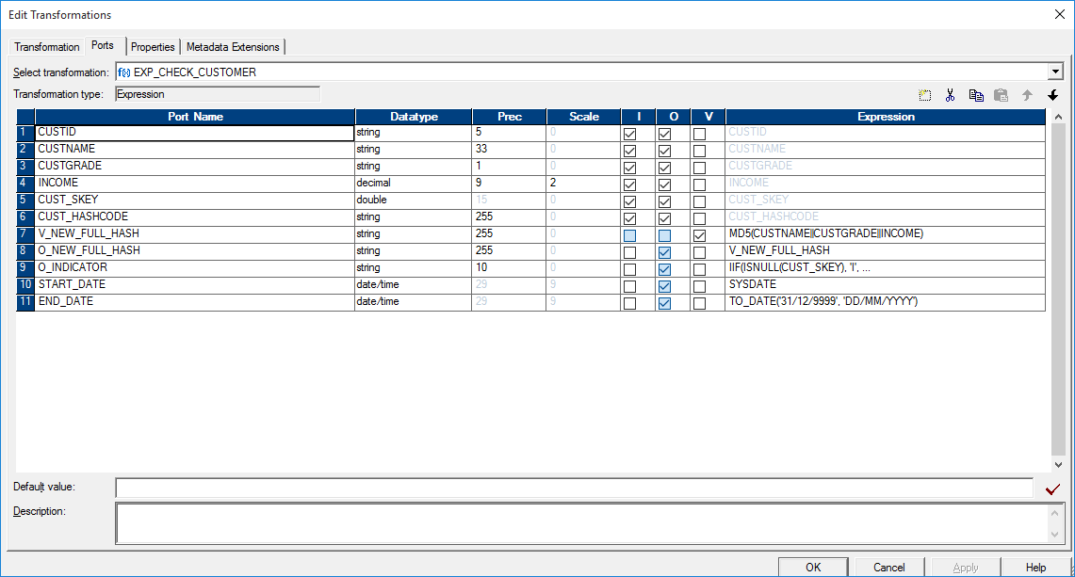

O_INDICATOR

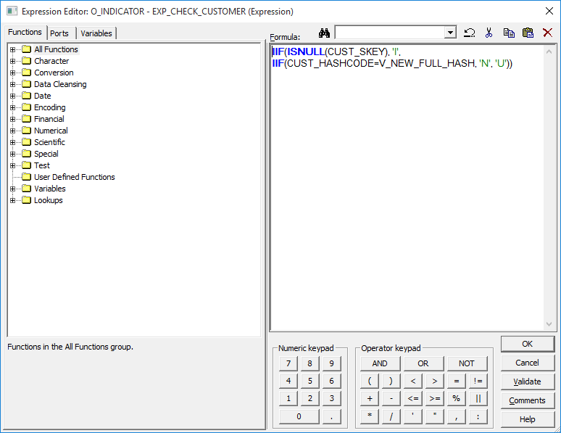

Others are visible in the screen only

In router create two groups

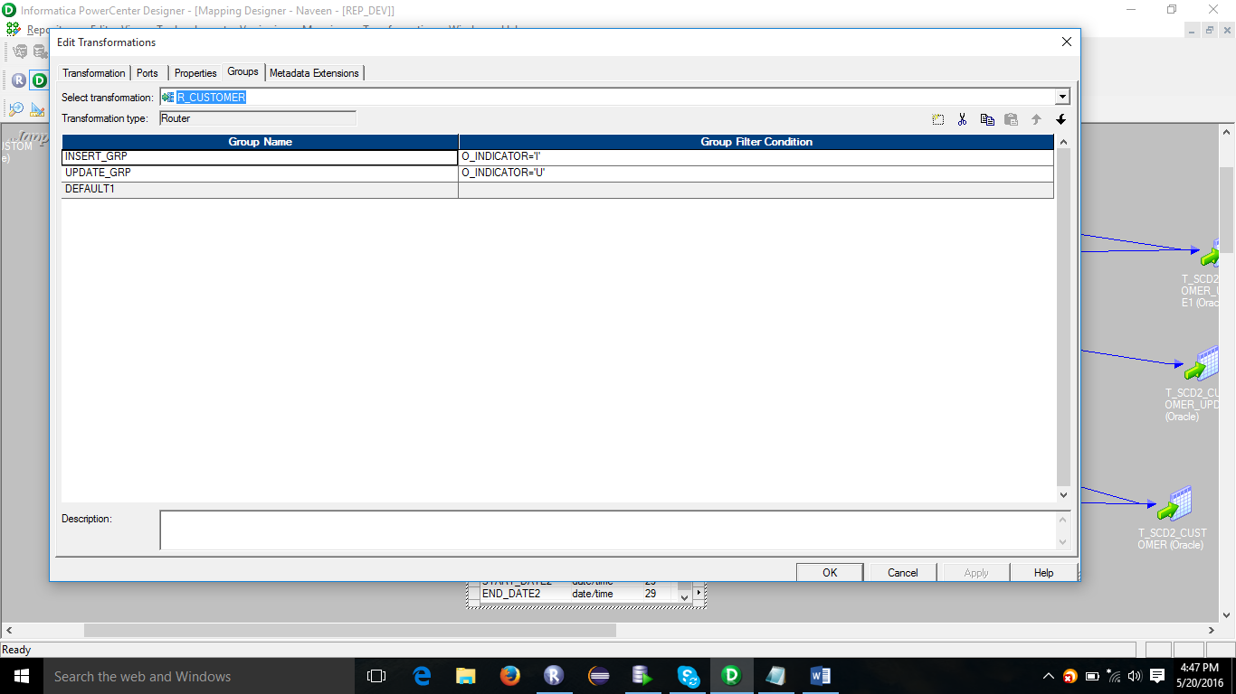

After router

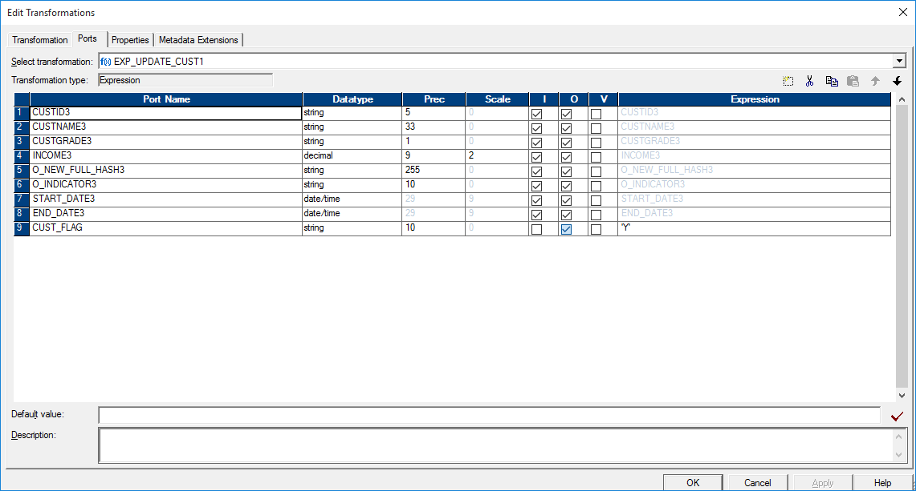

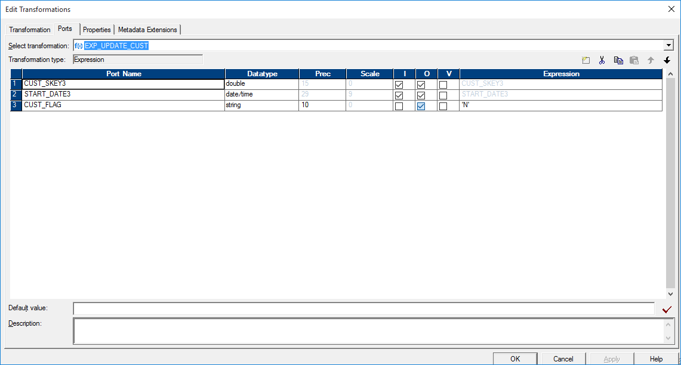

The above one give it only for existing record for update the flag to ‘N’ , give it to update strategy with DD_UPDATE

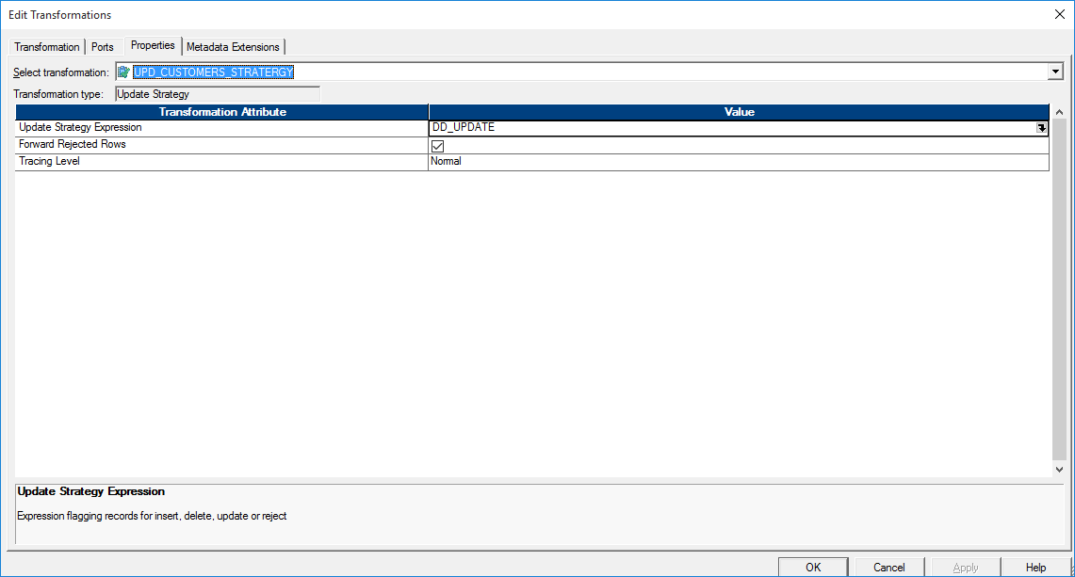

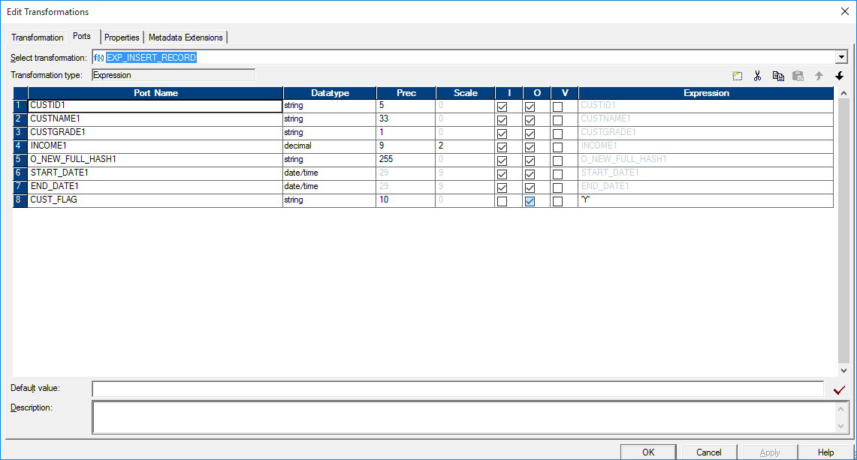

Final View

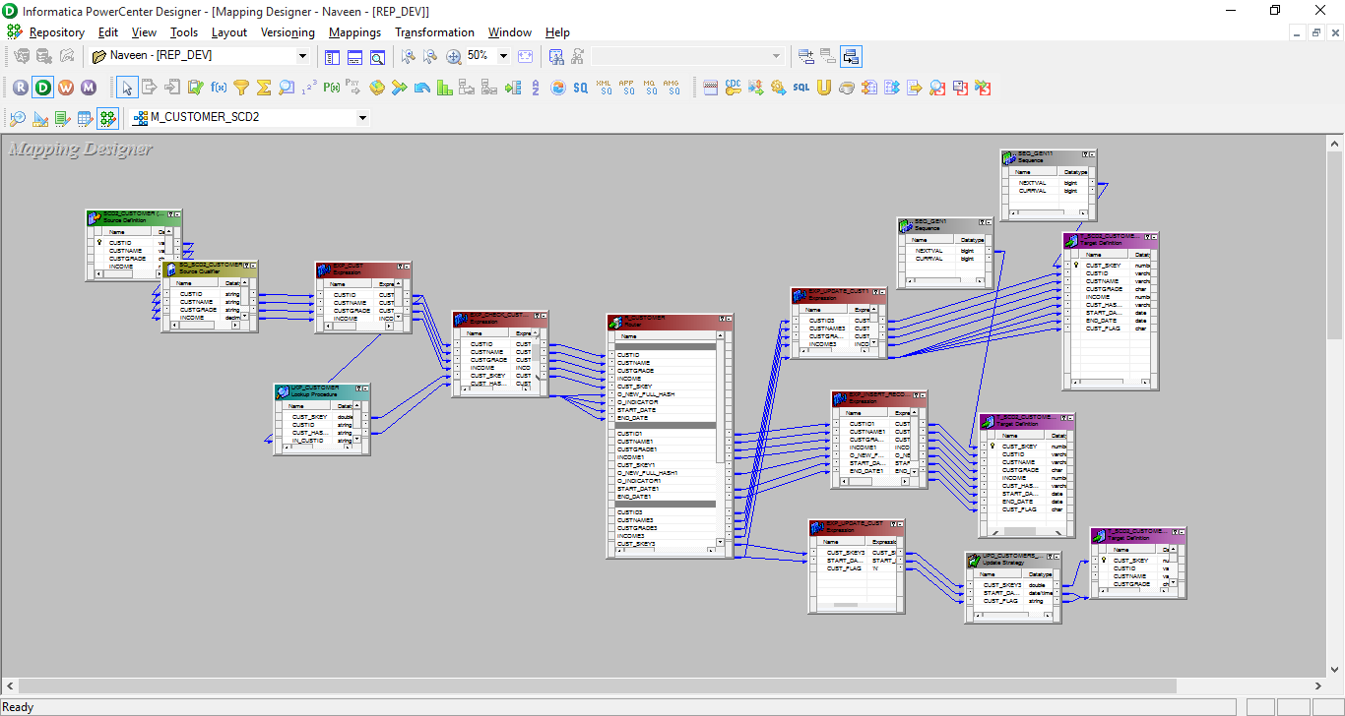

**Implementation of SCD Type 3**

CREATE TABLE SCD3_CUSTOMER(

CUST_ID NUMBER(10) PRIMARY KEY,

CUST_NAME VARCHAR2(30) NOT NULL,

CITY VARCHAR2(30),

STATE VARCHAR2(30));

INSERT INTO SCD3_CUSTOMER VALUES (101, 'KARTHIKA', 'RESTON', 'VIRGINIA');

INSERT INTO SCD3_CUSTOMER VALUES (102, 'SUNDAR', 'CUPERTINO', 'CALIFORNIA');

INSERT INTO SCD3_CUSTOMER VALUES (103, 'SCOTT', 'DELHI', 'DELHI');

INSERT INTO SCD3_CUSTOMER VALUES (104, 'VIJAY', 'DALLAS', 'TEXAS');

CREATE TABLE T_SCD3_CUSTOMER(

CUST_KEY NUMBER(30) PRIMARY KEY,

CUST_ID NUMBER(10),

CUST_NAME VARCHAR2(30),

CITY VARCHAR2(30),

STATE VARCHAR2(30),

PREV_CUST_NAME VARCHAR2(30),

PREV_CITY VARCHAR2(30),

PREV_STATE VARCHAR2(30),

CREATE_DT DATE,

UPDATE_DT DATE);